Configuring Bookings for Room Reservations
- Launch Bookings.
- Click 'Get it now'.
- Click 'Add a booking calendar'.
- Enter your business information.
- Verify your business information by going to the Business Information tab. Is all your information correct?
- Go to the Services tab and click Add a service to add your first room to your Bookings page. Name the service (e.g. Lab 1 – Lash Miller Room 101) and fill out the page details. When you get to the Staff section click Save. You will update the staff section later.
  - 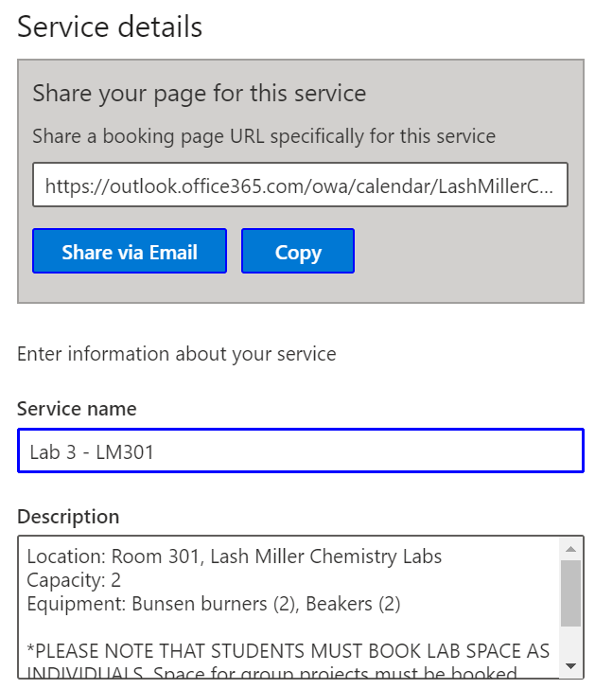
- Repeat step 6 for as many rooms as you need to add. Under the Service tab you should now have a list of rooms.
  - 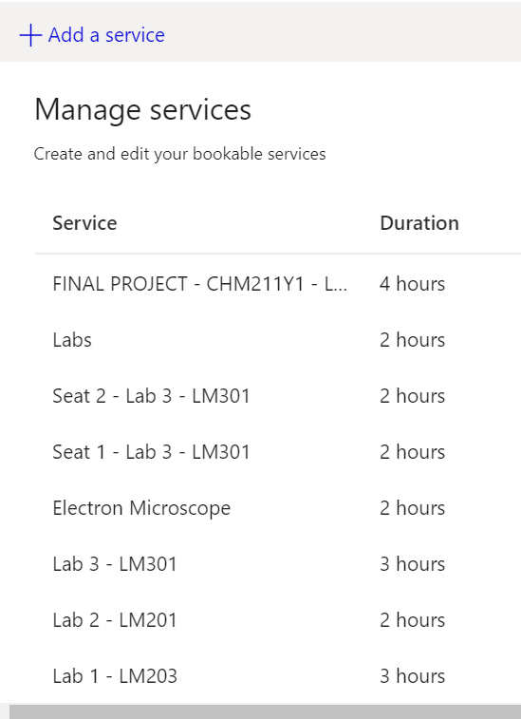
- Once you have added all your rooms under Services, click on the Staff tab in the sidebar. Click Add staff.
- Instead of adding information for a staff member, enter the information for a room that is listed under your Services tab.
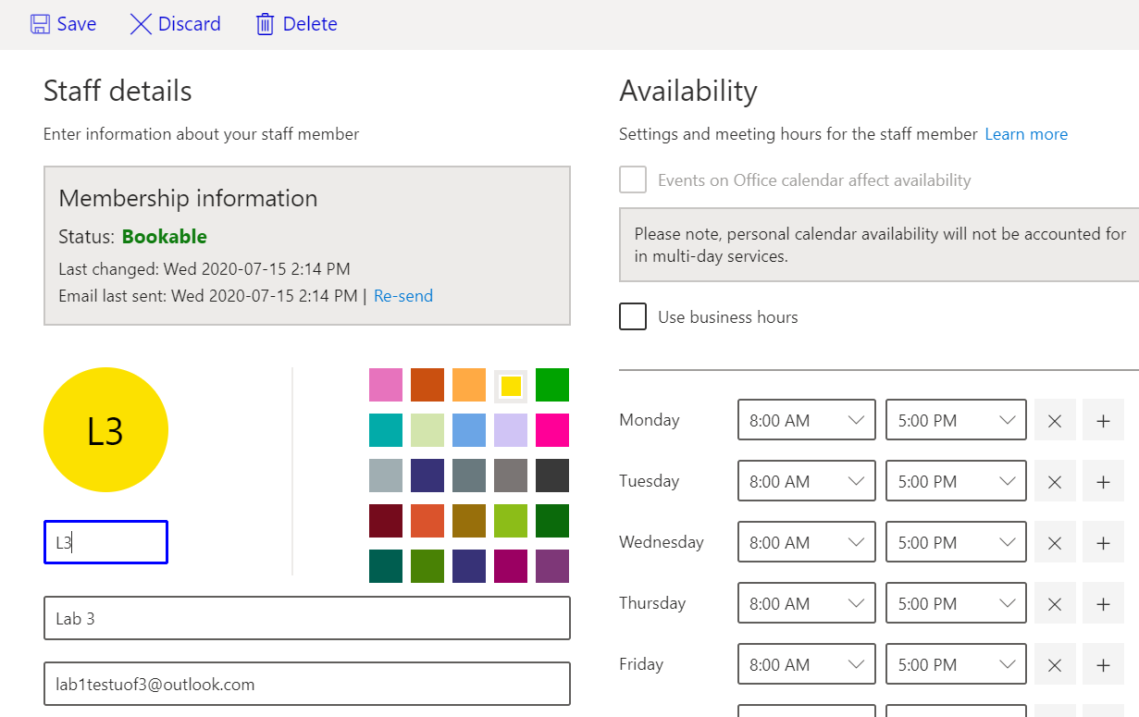
  - You must enter an email address. You can either enter a phony email address, or add the email address of a shared resource (see: Integrating Rooms with Shared Resources in Bookings).
  - Verify that the availability for your room listed under Staff matches the availability of the same room with the same name listed under Services.
  - When you have entered the information for the room click Save.
10. Repeat step 9 for all of the rooms listed under Services.
11. Go back to the Services tab and click on a room. Scroll to the Assign Staff section at the bottom of the editing interface.
12. You will see a list of all of the rooms you have just added to the Staff tab. Click on the “staff member” that matches the room. For example, if you have selected Lab 3 (Service) click on Lab 3 (Staff). You should see a check mark next to your selection.
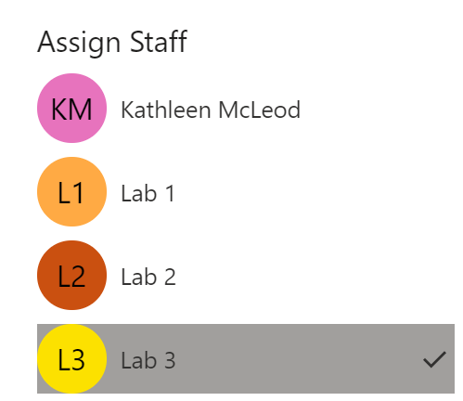
13. At the top of the page click Save.
14. Repeat step 12 for all rooms.
15. After reviewing additional settings, click on Bookings Page and then Publish to launch your page.

