Integrating Rooms with Shared Resources in Bookings
- Follow steps 1 to 9 as outlined in Configuring Bookings for Room Reservations.
- Instead of entering a phony email address for each “staff member” enter the email address of the corresponding shared resource. To find the email address of a shared resource:
  - Open your Outlook calendar.
  - Click on New event.
  - Click on the Invite attendees field and start typing the name of your shared resource.
  - When you locate the shared resource, click on it to add it to the event invitation. Once the resource has been added to your attendee list, click on it again to see more information.
  - You should see an email address for the shared resource under Contact information.
    - 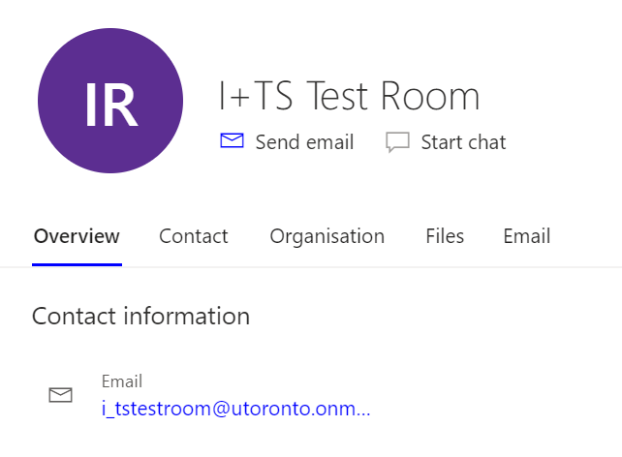
  - Copy the email address.
  - Paste the email address into the email field of the corresponding room under the Staff tab in Bookings.
    - 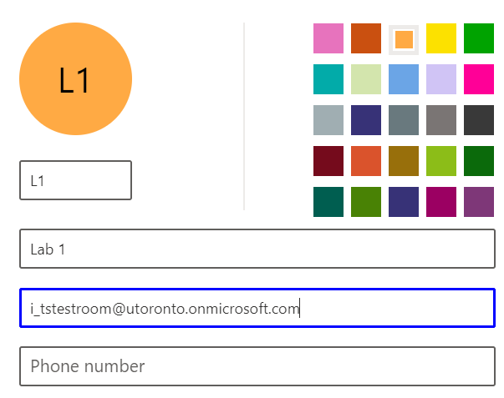
- Click Save.
- Repeat steps 2 to 3 for all rooms you would like to match with a corresponding shared resource.
- Go back to the Services tab and click on a room. Scroll to the Assign Staff section at the bottom of the editing interface.
- You will see a list of all of the rooms you have added to the Staff tab. Click on the “staff member” that matches the room. For example, if you have selected Lab 3 (Service) click on Lab 3 (Staff). You should see a check mark next to your selection.
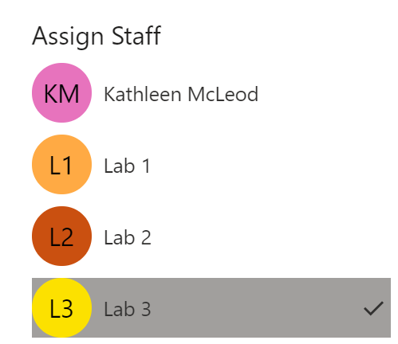
- At the top of the page click Save.
- Repeat step 7 for all applicable rooms.
- After reviewing additional settings, click on Bookings Page and then Publish to launch your page.

Now all new reservations made for rooms that are linked to a shared resource will be reflected in that shared resource’s calendar.

