This guide is for quick reference. More details are available online on the EMS Documentation Website in the EMS for Microsoft Outlook User Guide section.
Create a Meeting with the EMS for Desktop Outlook Add-in
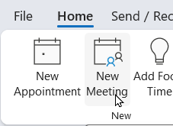
- Open Outlook and select New Meeting.

- Complete the meeting information: Title, Attendees, Start and End Date/Time.
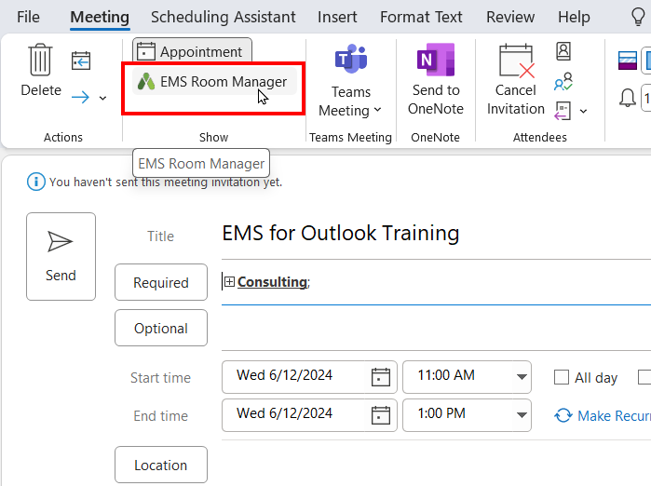
Select the EMS Room Manager icon in the ribbon menu.

- Select the template for your request.
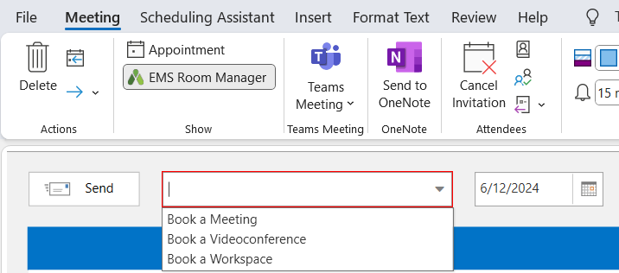
- Select either the List View or the Schedule View.

List View shows rooms available for the selected date and time.
If filter items are selected, the list view shows rooms that fit the filter criteria.
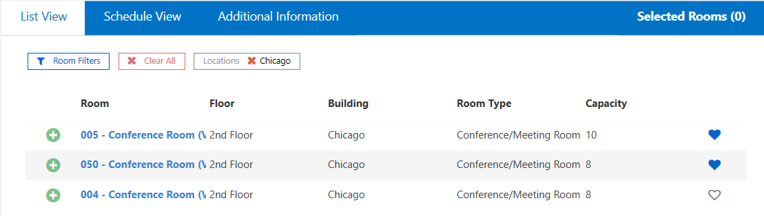
Schedule View show all rooms in the selected building.
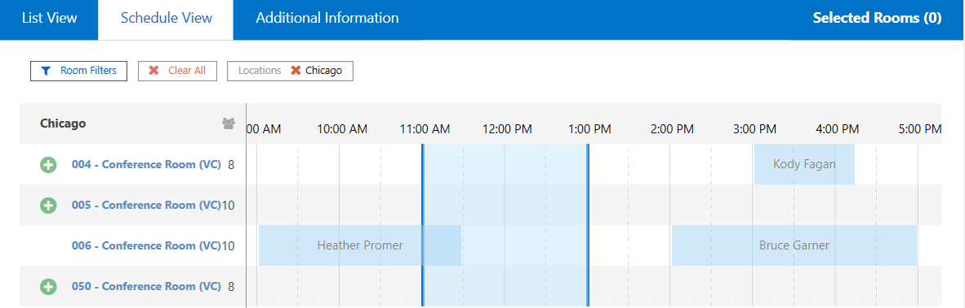

- Select the Green + button next to the name of your preferred room(s).
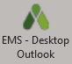
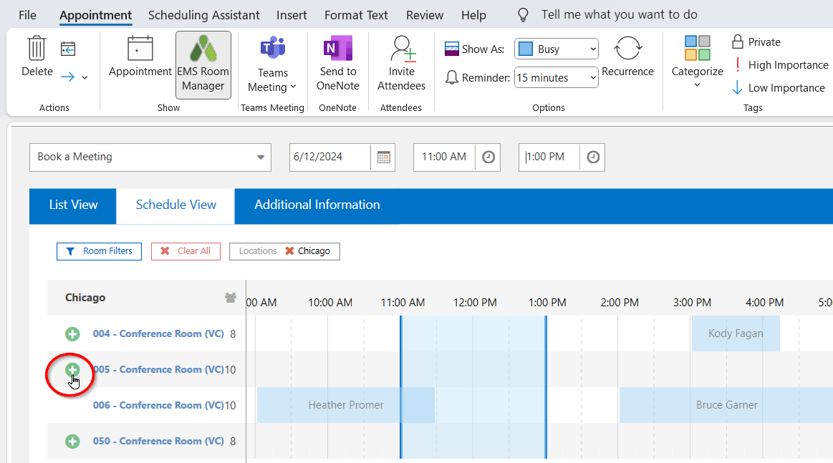
- Enter the Setup Type and count (if required) for each room you select and click Done.
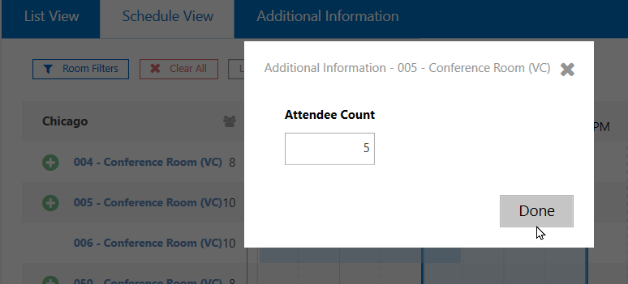

- Click to the Services tab if available to add services.
Selected services display on the right in the Services Cart.
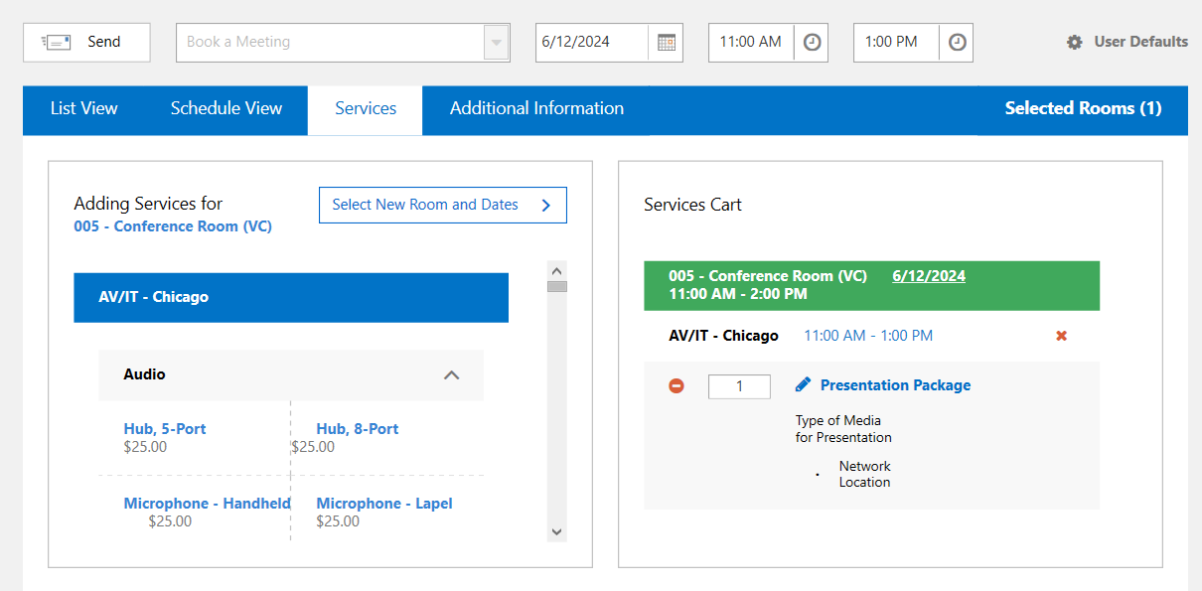
- Complete the Additional Information tab if available.
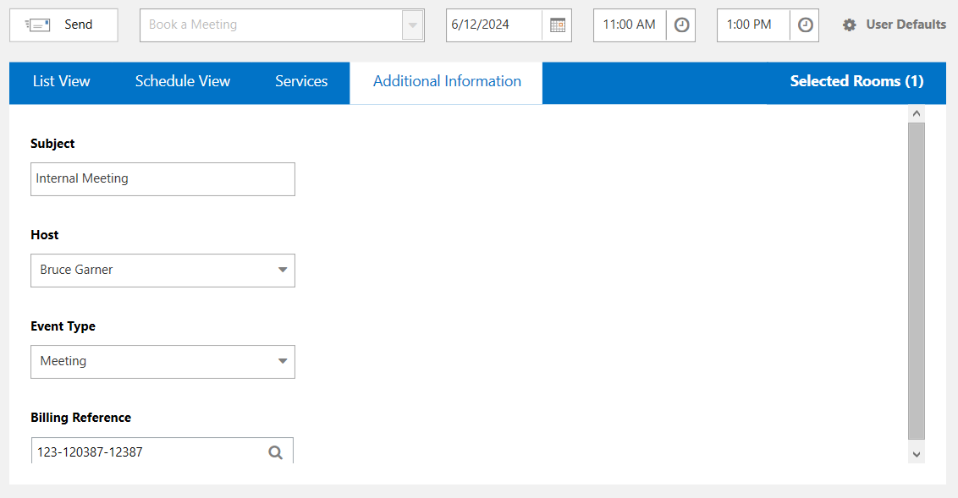
- Click Send in the EMS Room Scheduling window.
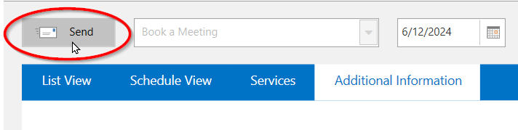

Manage your Bookings:

Date, time, room location and service changes are managed in the EMS Room Manager function of Outlook or in the EMS Web App or EMS Mobile under My Events.

EMS for Outlook Helpful Information:
Click on the name of a room to see room details, setup types, features and images
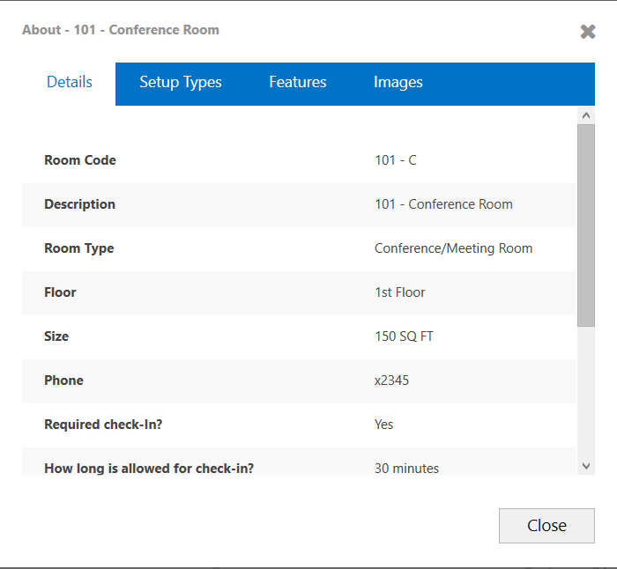
Select Schedule View to see meetings booked in other spaces for the day. Hover over each booking for more details.
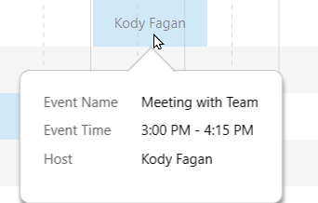
Use filters to display a list of room that fit your meeting needs.

